Confusion Matrix
In this article i will try to explain confusion matrix using two examples.
The first example is a patient is healthy or sick and the second example will be a spam detector.
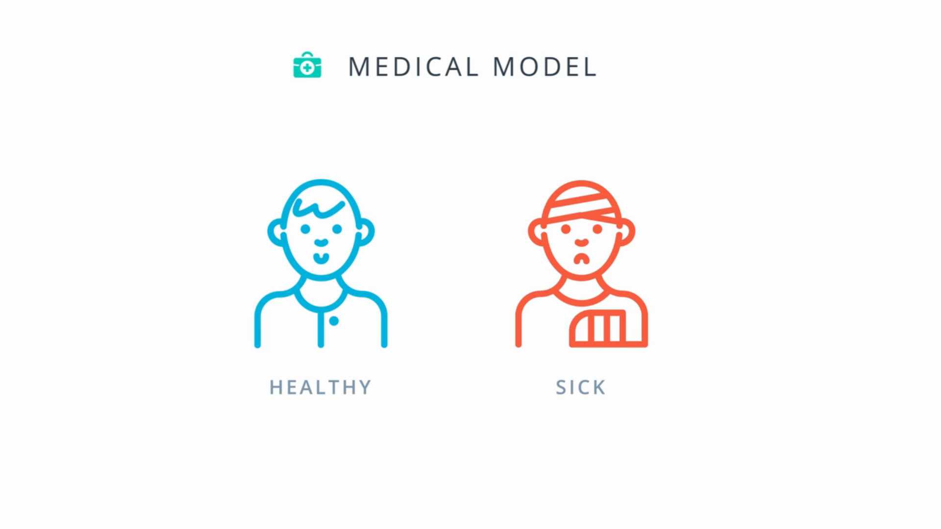
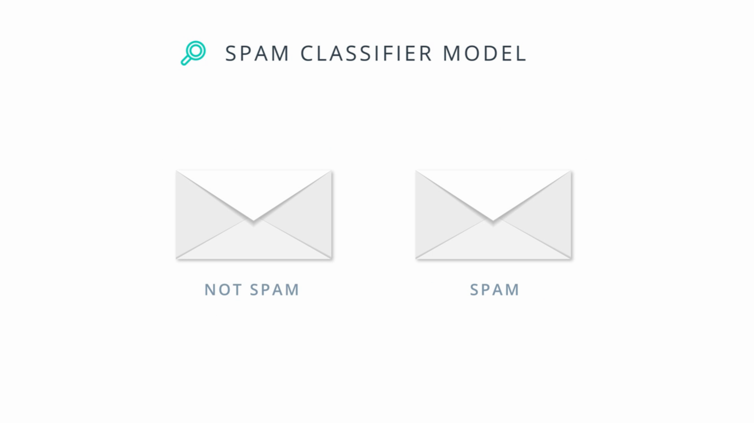
So, now let’s see with an example what confusion matrix looks like for a medical model.
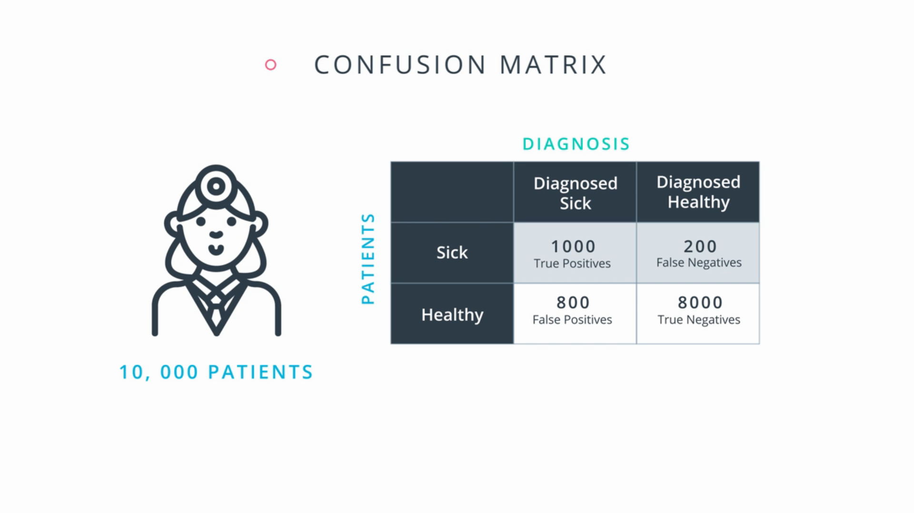

In the above confusion matrix table we have the performance a model, In that model we have 10,000 patients.
A 1000 of them are sick and the model have been correctly diagnosed them as sick so we call them as True Positives.
A 200 of them are sick and the model have been incorrectly diagnosed them as healthy so we call them False Negatives
A 800 patients are healthy and the model have been incorectly diagnosed them as sick, so we call them as False Positives.
And finally 8000 patients are healthy and the model correctly diagnosed them as healthy, so we call them as True Negatives.
The confusion matrix is a simple table that stores these four values.

Now lets’s look at the second model for detecting spam emails.
Here we have thousand emails
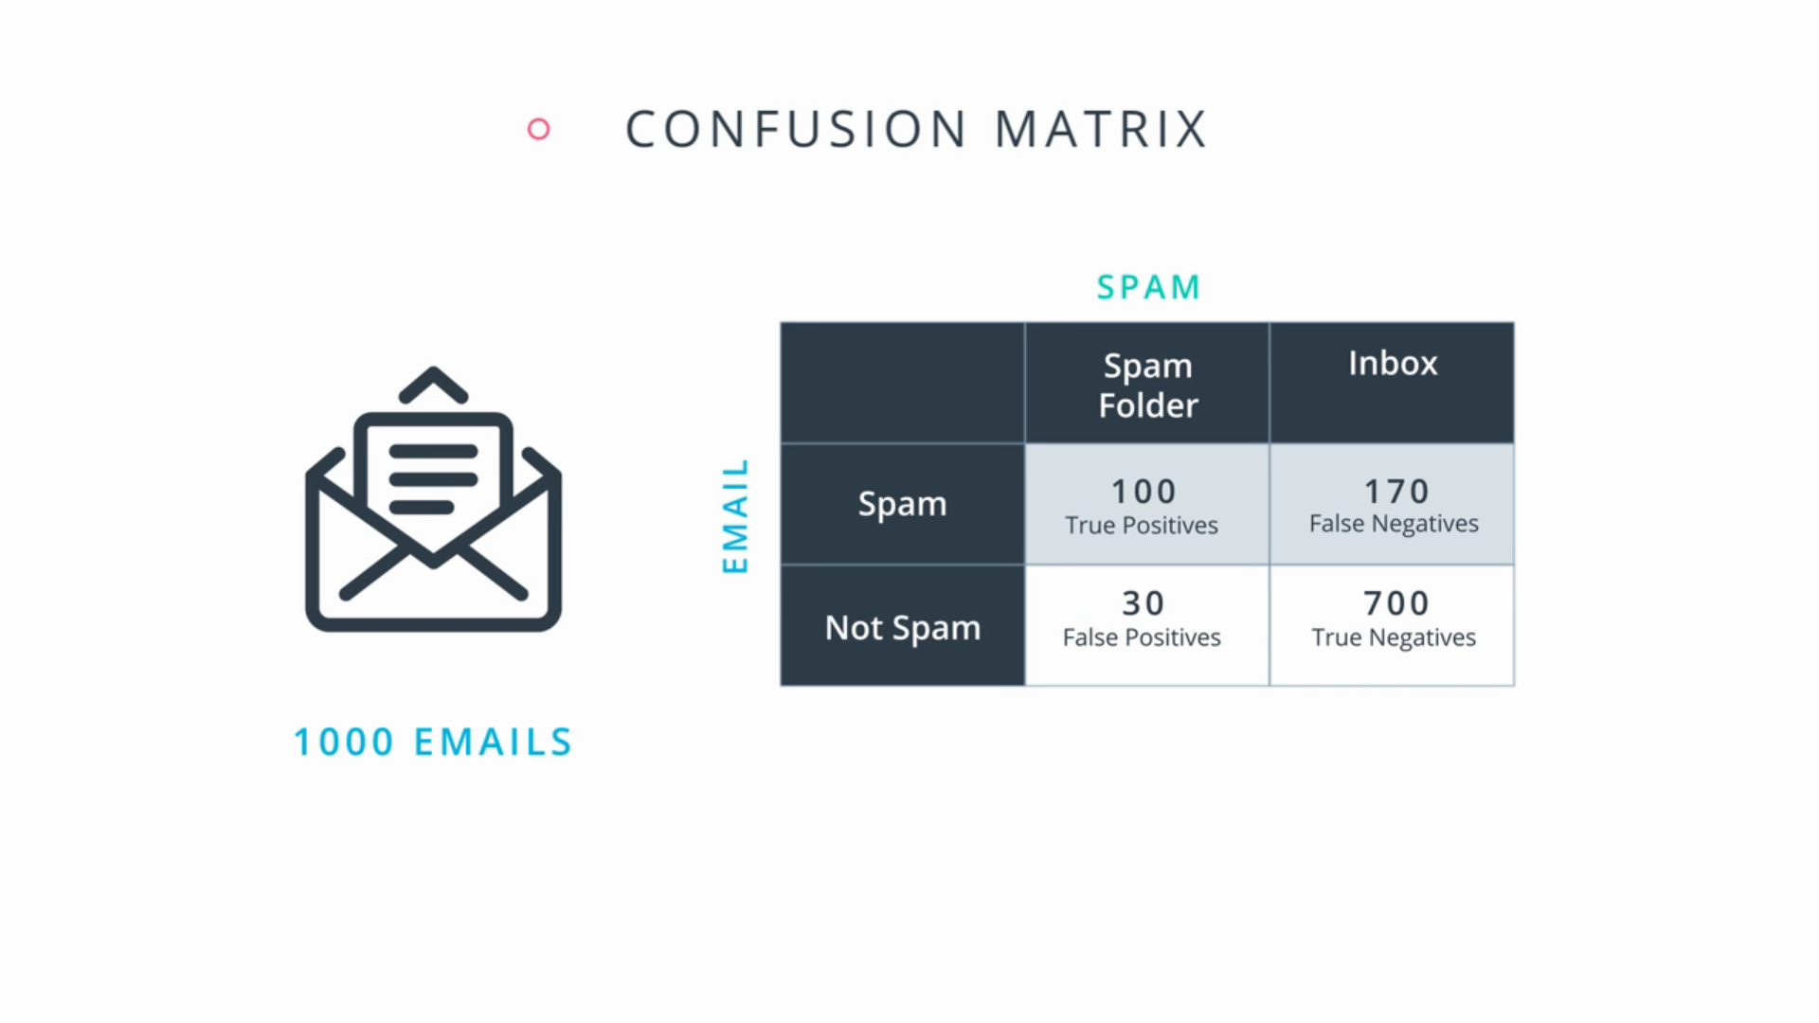

Out of these 1000 emails,
A 100 spam emails have been correctly sent to the spam folder we call them as True Positives.
A 170 spam emails have been incorrectly sent to the inbox we call them as False Negatives.
A 30 non-spam emails have been incorrectly sent to the spam folder we call them as False Positives.
And finally, 700 non-spam emails have been correctly sent to the indox we call them True Negatives.

Ok now lets get back to our medical model, where we had 4 cases True positive, True Negative, False Positive and False Negative. Let’s forget about the two correct ones i.e (True Positives & True Negatives) and only focus on the mistakes i.e (False Positives & False Negatives).
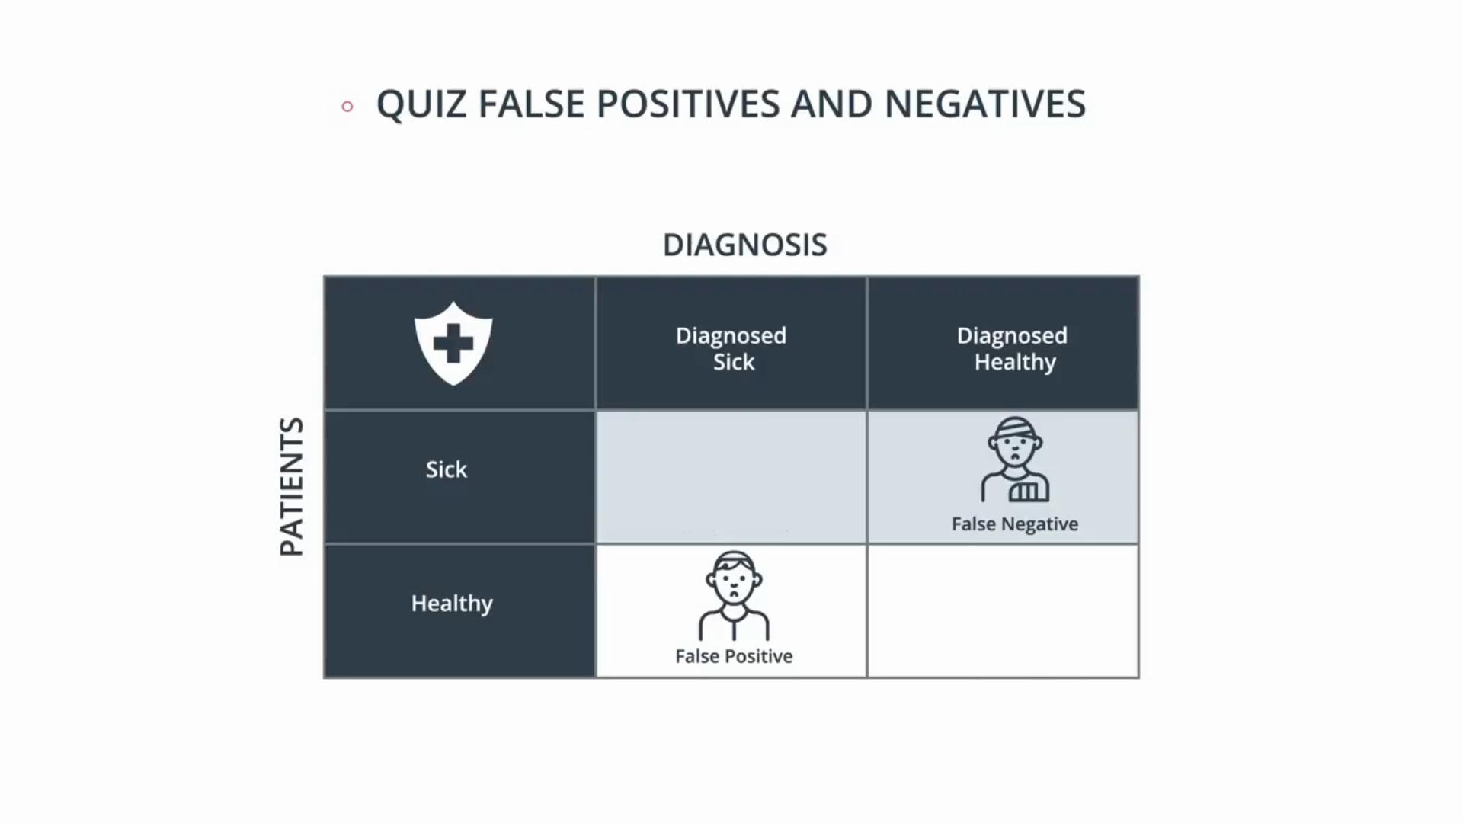

So which one do you think is worse fasle positives or false negatives?
For this medical model it seems that we’d much rather misdiagnose a healthy person as sick and send him for more tests than misdiagnose a sick person as healthy and send him home without treatment.
In this case, a False Negative (When a patient is sick but the model incorrectly diagnosed him as healthy) is much worse than a False Positive (When a patient is healthy and the model incorrectly diagnosed him as sick)
So the rule of this model is i want to find all the sick people, i’m okay if i accidentally bring some more that are sick, but i need to find all the sick people.

Now let’s see for the Spam email model where we had 4 cases True positive, True Negative, False Positive and False Negative. Let’s forget about the two correct ones i.e (True Positives & True Negatives) and only focus on the mistakes i.e (False Positives & False Negatives).
A False Negative means a spam email made its way into your inbox, and all you had to do is DELETE it!. So it’s a bit of an inconvenience, On the other hand, What’s a False Positive?
Your Girlfriend’s mail, she have typed a mail to tell you to be on Saturday night for the Date, and you delete it. That’s terrible!. So here, we want to punish false positives more than false negatives. So this model basically says, “I don’t really care if i find all the spam emails but one thing is for sure if i say that an email is spam it better be a spam.”

So as we can see, the medical model and the Spam email model are fundamentally different.
The medical model as we saw is okay with False positives(When a patient is healthy and the model incorrectly diagnosed him as sick) but not with False negatives(When a patient is sick but the model incorrectly diagnosed him as healthy), since we’re okay misdiagnosing some patients as sick as long as we find all the sick people.

The Spam email model on the other hand is okay with False negatives(When a email is spam model incorrectly send it to inbox) but not with Fasle positives (When a email is Not spam model incorrectly send it to spam), since we don’t necessarily need to find all the spam emails but one thing is for sure, that if we do label something as spam, it better be spam.

For this, we introduced two metrics, Precision and recall (I will explain these guys in upcomming article)
They will measure the exact things that we want, namely
the medical model needs to high in recall model and the email model needs to be high in precision model.

